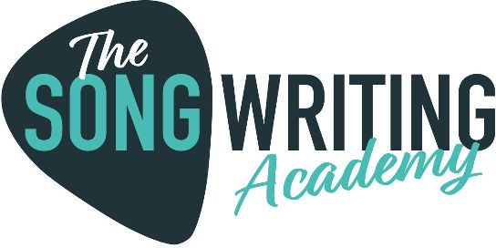

Your Goals

Name

Alan Riggs

What are your long term goals in music?

Make a full-time living income

Make music every week

What are your goals in music for the next 12 months?

Build up a catalogue of licensable songs.

Pitch them to supervisors and /or libraries

How do you want The Songwriting Academy to help you?

Songwriting tools

Lyric strategies